Project Design Phase-I

Solution Architecture

|  |  |
| --- | --- |
| Project Name | PERSONAL EXPENSE TRACKER APPLICATION |
| Team ID | PNT2022TMID26431 |
| Team Members | VARSHIDH R  SELVAM M  SUBASH B  VIDHYA D |

SOLUTION DESCRIPTION:

The solution to this problem is, the people who gets regular payments can able to track their payments and know how much you can spend daily in order to stick to your target. There will be alerts for the spending. If the spending limit exceeds means there will be alerts. The application gives proper analyses of our expenditure and income. It reduces man power for accounting and financing the money, human errors can be eradicated.

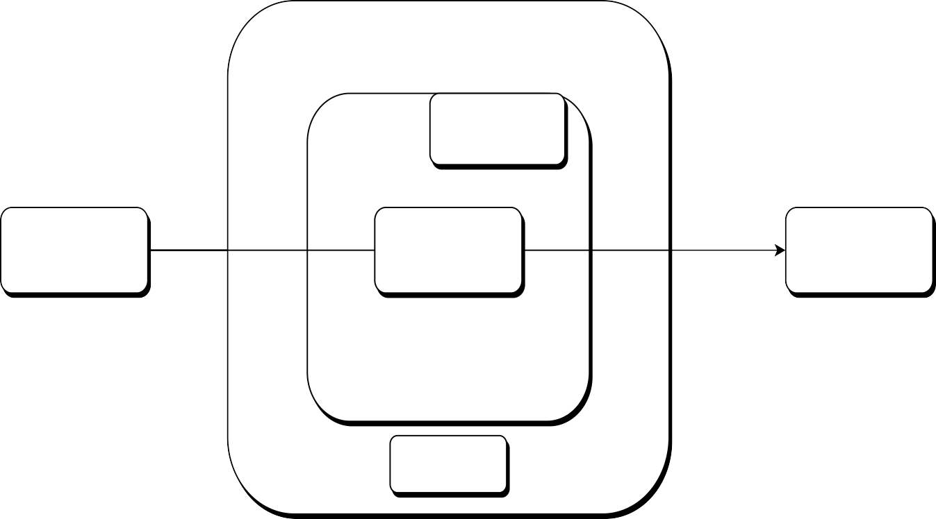

**Kubernetes**

**Container**

**User/Customer**

**Personal Expense**

**Tracker**

**Email**

**Alerts**

**SendGrid**

**Platform**

**Docker**

**Container**

**Personal Expense Tracker (Solution Architecture)**